

**News Letter – october 13, 2012**

**Renewal CAMPAign**

**UPDATE – CONSTRUCTION PROJECT**

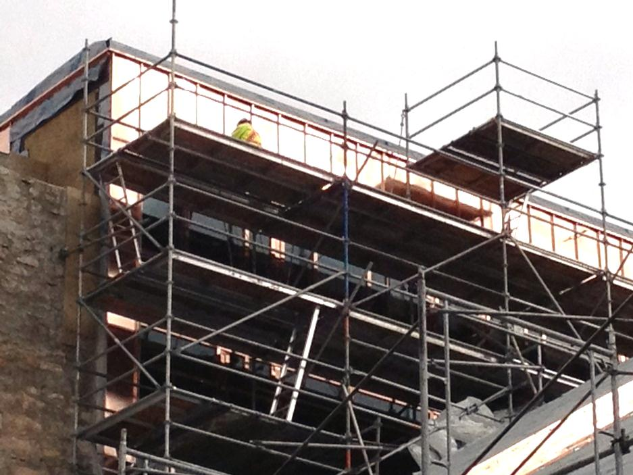***FEATURING COPPER***

You've probably noticed the remarkable progress on the Cathedral’s roof.

Fastening the impressive copper changes the appearance of the church and is attracting the attention of many people walking on de la Cathédrale Avenue.

This new surface will ensure lasting protection against the elements of Mother Nature for 100 years.

**Book Launch, written by Pascale Dalcq**

***‘Et votre joie sera parfaite’***

**All proceeds will be donated to the Renewal Project**

**Oct 23, 2012**

**OVERVIEW OF THE CATHEDRAL’S VISION SESSION**

**More projects and more resources**

Sixty people attended the October 2nd VISION session on the St. Boniface Cathedral’s Renewal Project. The event was a success on many levels as it allowed participants to better understand the scope of the project.

**A Three-Step Evening**

Our three guests of honour for the evening included the President of the company **Scatliff + Miller + Murray**, Michael Murray, the President and CEO of **The Winnipeg Foundation**, Rick Frost, and the Cathedral of Saskatoon’s official fundraiser, **Don Gorsalitz**. Father Marcel Carrière delivered the opening speech and each guest had the opportunity, in turn, to present their vision for the St. Boniface Cathedral’s Renewal project.

The first speaker, Michael Scatliff, presented the Master Plan for the development of the Red River in Winnipeg, "River City Connections", which aims to reinvent the banks of the river in order to integrate them into a nice public walking area. "This vision includes the neighborhoods of The Forks and St. Boniface,” he explained. “It goes without saying that the St. Boniface Cathedral is an integral part of the project due to its cultural, educational and historic value. It will be an essential stop in the circuit.”

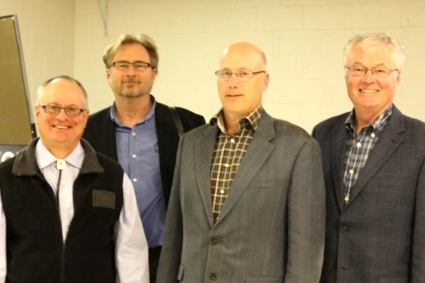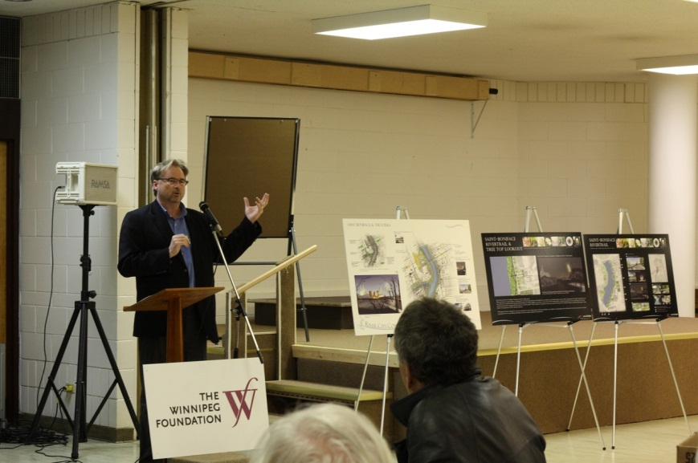

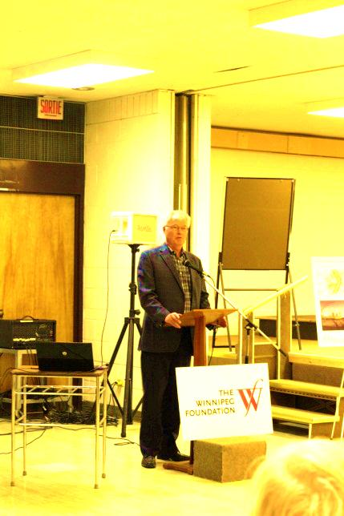

**A Large Donation from the Winnipeg Foundation**

Rick Frost was the second speaker and introduced the City’s strategy to promote green spaces, where he also announced the new funding to the audience: "The **Winnipeg Foundation** is pleased to donate **$ 150,000** to the St. Boniface Cathedral, to support its Renewal project." This news was greeted with a thunderous applause. Finally, Don Gorsalitz talked about his fundraising experience for the renovation project of the Saskatoon Cathedral, in Saskatchewan. His speech was intended to demonstrate that with will power and perseverance, the greatest ambitions are attainable.

**A Necessary Visit**

Following the explanation of the theoretical background of the Cathedral’s Renewal project, all Vision session participants were invited to visit the interior of the building to become familiar with the inherent shortcomings.

The workshops were an important portion of the session, which allowed the participants to split up into small groups in order to identify the premises’ renovation priorities. People from the parish and the Francophone community gathered around a dozen round tables and shared their ideas before the noting them on paper.

“This session was particularly interesting,” expressed Gilberte Proteau, one of the participants.

“To this day, I do not know everything about the Renewal Project. This gathering allowed me to learn more. And it is very encouraging to know that it is supported by the City! The Renewal project is a great initiative. The Cathedral will be able to play the role for which it was created, namely the role of unification and assembly for all. In this regard, I think we should first make changes to the community hall, to make it more welcoming. It is also important to completely renovate the bathroom and kitchen for more possibilities.”

Another participant, Normand Boisvert, who also shared this view, enjoyed the session because it enabled him to better understand the different perspectives of the Renewal project and discover new areas within the Cathedral. In his opinion, both the interior and the exterior spaces are worthy of attention. "The basement is a priority, but we must also solve the problems of roof and strengthen the walls,” he noted. “The renovations should be representative of 2012 and beyond. 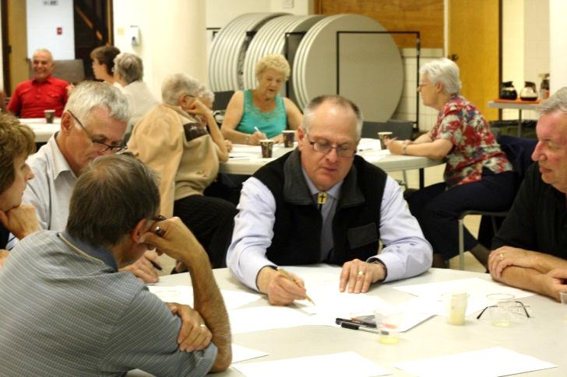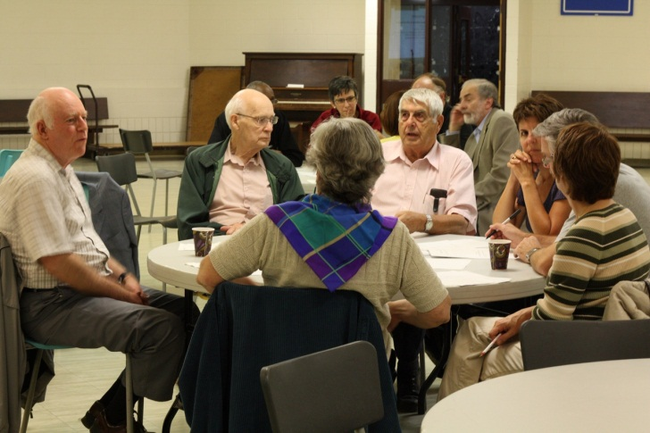

*NB – Anybody who did not participate in the session but would like to provide feedback are encouraged to pick up the questionnaires at the parish office and hand them in during collection.*

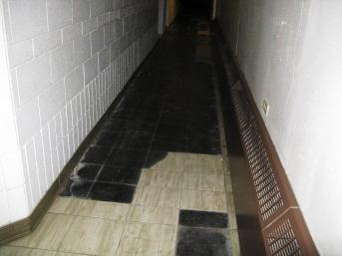**Specific Priorities**

Furthermore, for Claudette Savard and Jules Chartier’s group, it is not only important to clean, upgrade and secure the premises, but to also focus on the equipment. “From a visual point of view, it would be interesting to improve the multimedia room by installing a good projection system, which would also include sound, lighting, and ventilation,” Claudette Savard noted.

Finally, according to parishioner Jeannette Couture, the ultimate goal of the Vision project is to create a gathering place and to revive the entire community. This is the most important aspect for her. “I hope that the Renewal will attract more people and revive a sense of belonging among the community,” she said. “We need to create a warm and open environment for everyone, so that people feel at home here. We should be favouring the surrounding areas and not the place of worship.”

**Renewal Campaign – $6,000,000 Objective**

**October 4th, 2012 Results**

**Parish Community**

Questions?

Would you want to meet a member of the committee to discuss donation options?

Do not hesitate to contact one of the following:

Normand Boisvert : (204) 221-6964

René Fontaine : (204) 231-3234

Carmen Laroche : (204) 233-6034

Philip Lavack : (204) 257-4040

Francis Labossière : (204) 237-1276

Raynald Labossière : (204) 233-4982

Denis Marion: (204) 237-6636  
Agnès Rémillard : (204) 253-8148

Réal Sabourin : (204) 231-0592

Claudette Savard : (204) 233-6079

**$1,400,000 $4,600,000**

.

$812,620

= 58%

of our target goal

$1,739,915

= 38% of our target goal