Newsletter – November 11, 2012
Renewal Campaign

Construction Project News
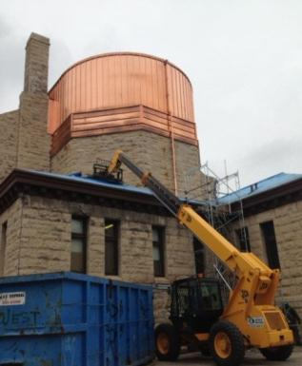
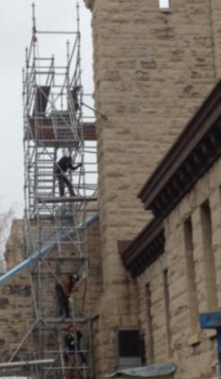
‘’Il pleut, il mouille, c’est la fête à la grenouille’’. It is a beautiful French nursery rhyme, but unfortunately this weather is preventing further progress on the roof. Early November was estimated as the completion date for this phase of construction. We hope that the sun will reappear and that the snow will delay its arrival for a few weeks to allow Flynn Roofing to complete their work. We are confident that this phase will be completed by mid-December.

Good news: we are still within budget for this phase of the work.

A Successful Book Launch: « Et votre joie sera parfaite », written by Pascale Dalcq
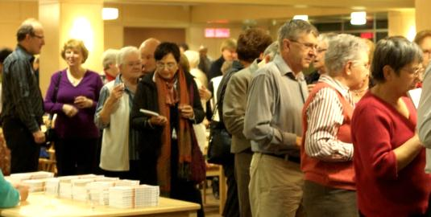
On October 23, 2012, approximately 150 people gathered at the Villa Aulneau for Pascale Dalcq’s book launch. Organized by the Cathedral Parish, the event included speeches by Archbishop Albert LeGatt, Sr. Cecile Fortier, René Fontaine and Pascale Dalcq, followed by a toast by Father Marcel Carrière. Excellent musical entertainment was provided by Nathanael Wsiaki and Elise Lavallee.

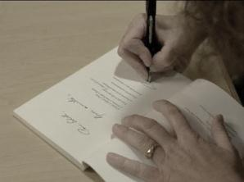
The book, entitled "Et votre joie sera parfaite" is above all a testimony of faith and the wonderful journey of a person who experienced great suffering. Pascale pointed out that despite completing the 130-page manuscript within the space of two months, it was not easy task and she truly appreciated the encouragement of her many friends. By sharing this story, Pascale hopes that it will be helpful to others: "If one person can enjoy the book, it will be worth it," she confided to the audience.
The evening ended with a toast. Wine was sponsored by Bockstael Construction. Proceeds of the book ($ 20 per copy) will be given to the Cathedral’s Renewal project. Copies are available at the Parish office, at Librairie à la Page and at La Boutique du livre.

Results of the Parish Campaign launched September 23, 2012 - Goal $1,000,000
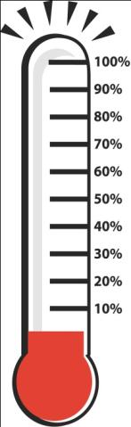
.
Questions?
Would you like to meet a member of the committee to discuss donation options?

Do not hesitate to contact one of the following:

Normand Boisvert : (204) 221-6964
René Fontaine : (204) 231-3234
Carmen Laroche : (204) 233-6034
Philip Lavack : (204) 257-4040
Francis Labossière : (204) 237-1276
Raynald Labossière : (204) 233-4982
Denis Marion: (204) 237-6636
Agnès Rémillard : (204) 253-8148
Réal Sabourin : (204) 231-0592
Claudette Savard : (204) 233-6079
We are pleased to inform you that since the beginning of the official launch of the campaign on September 23rd, we’ve received $188,665 in donations and commitments from parishioners, which accounts for 19% of our goal.

In the coming weeks, members of the Parish Pastoral Council and the Economic Affairs Parish Committee will offer guided tours of the Cathedral to demonstrate our church’s real needs. You will be encouraged to submit comments and suggestions afterwards. These comments will be compiled with those who participated at the last Vision session.

Launch of the Renewal’s telephone campaign
Last week at the end of each Mass, Normand Boisvert gave an update on the Cathedral’s Renewal project. It was communicated that members of the parish committee and two members of the campaign have begun a telephone blitz to parishioners who have not yet committed. These calls are designed to see if the person has received the information, if they need more information or if they want to meet a member of the committee to discuss contribution options, as well as to answer any possible questions.

Province of Manitoba Announcement Imminent!
We are in discussions with the Province of Manitoba to organize a funding announcement soon. We would like this event to take place in conjunction with the completion of the roof and the sanctuary’s large window in early December. We will keep you informed of this pending announcement!

City of Winnipeg Historical designation?

Although the Cathedral is recognized as a provincial heritage site, it is not yet designated as a municipal historical site. We have been working with the City of Winnipeg for several months to ensure that the St. Boniface Cathedral receives this designation. We should know the results of these efforts within the New Year. A special thank you to Philippe Mailhot, Gilles Lesage, Michel Lagacé, Gerald Labossière and Pascale Dalcq for their time spent on this issue!

